Name:
Plant Guide
As you walk along the path, locate plants and draw and describe them in this plant guide. Draw at least two.
Drawing | Description | Color | Texture/Pattern | Height
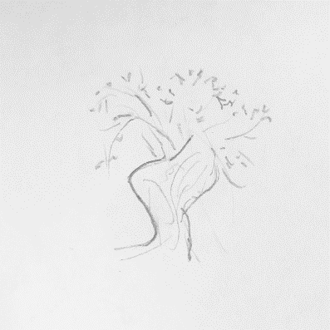 | Tight curled needles, windy bark, tree | Grey/tan bark, light green needles | Scraggily, rough and looks like bark is pulling away from tree | Twice as tall as me

Journaling
Draw, write a story, write a poem, etc. for the following prompt:
If you were a plant living on the edge of Grand Canyon, what would you see, feel, and hear?

